**Full Stack Development with MERN**

**Database Design and Development Report**

|  |  |
| --- | --- |
| Date | 20 July 2024 |
| Team ID | SWTID1720110658 |
| Project Name | Book Nest |
| Maximum Marks |  |

**Project Title**: Book Nest

**Date**: 20 July 2024

**Prepared by**:

Shreya Agarwal (TEAM LEADER) 22BCE2179

Monesha Ra 22BPS1190  
 Venu Gopal 22BCE2829  
 Anisha Plawat 22BCE0275

**Objective**

The objective of this report is to outline the database design and implementation details for the **Book Nest** project, including schema design and database management system (DBMS) integration.

**Technologies Used**

* **Database Management System (DBMS):** MongoDB
* **Object-Document Mapper (ODM):** Mongoose

**Design the Database Schema**

The database schema is designed to accommodate the following entities and relationships:

**1** **Books**

* Attributes: _id, authorName, bookTitle, category, bookDescription, imageURL, bookPDFLink, price

2 **Cart**

* Attributes: _id, bookId, authorName, bookTitle, category, bookDescription, imageURL, bookPDFLink, price, quantity

3 **Wishlist**

* Attributes: _id, bookId, authorName, bookTitle, category, bookDescription, imageURL, bookPDFLink, price

**Implement the Database using MongoDB**

The MongoDB database is implemented with the following collections and structures:

Database Name : BookStore

1**. Collection: bookCollection**

- Schema:

{

"_id": "ObjectId",

"authorName": "String",

"bookTitle": "String",

"category": "String",

"bookDescription": "String",

"imageURL": "String",

"bookPDFLink": "String",

"price": "String"

}

2. **Collection: cartCollection**

- Schema:

{

"_id": "ObjectId",

"bookId": "ObjectId (references bookCollection)",

"authorName": "String",

"bookTitle": "String",

"category": "String",

"bookDescription": "String",

"imageURL": "String",

"bookPDFLink": "String",

"price": "String",

"quantity": "Number"

}

3. **Collection: wishlistCollection**

- Schema:

{

"_id": "ObjectId",

"bookId": "ObjectId (references bookCollection)",

"authorName": "String",

"bookTitle": "String",

"category": "String",

"bookDescription": "String",

"imageURL": "String",

"bookPDFLink": "String",

"price": "String"

}

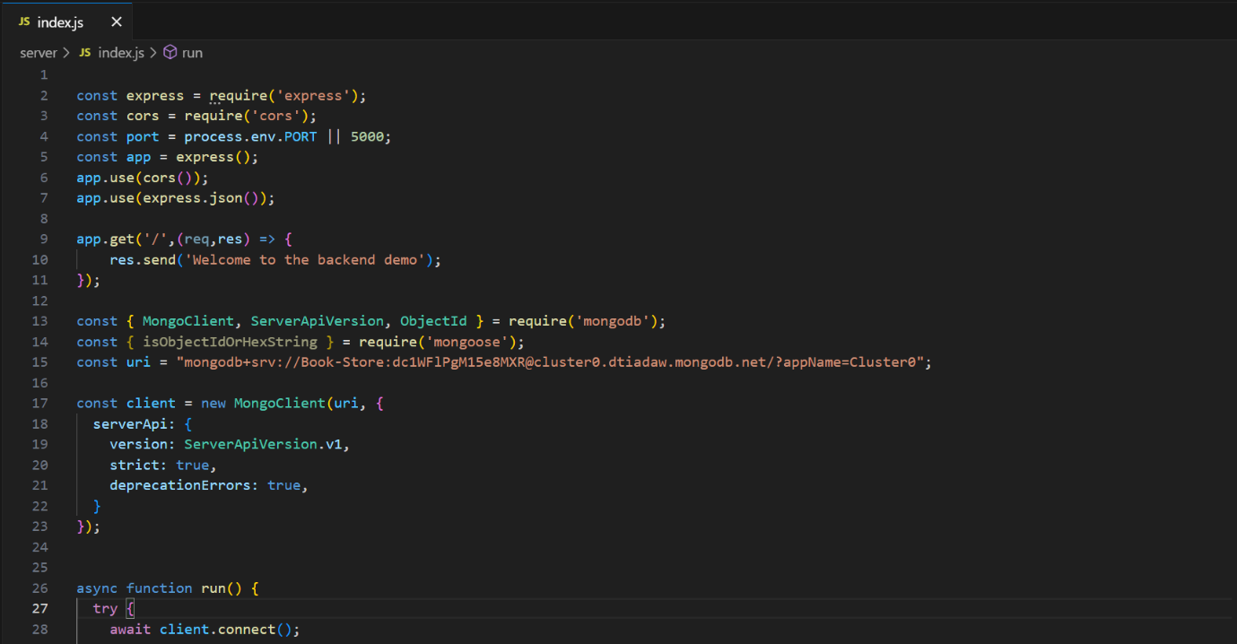**Integration with Backend -** Database connection

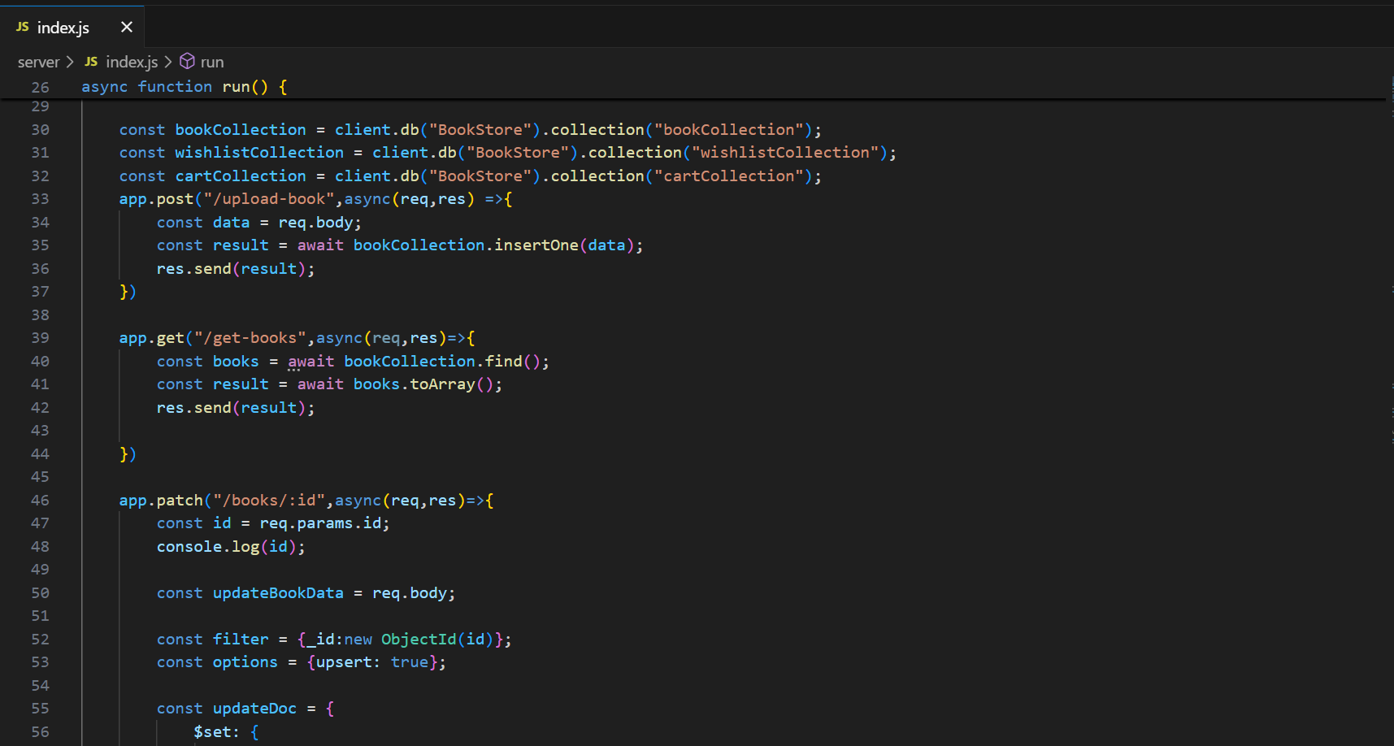

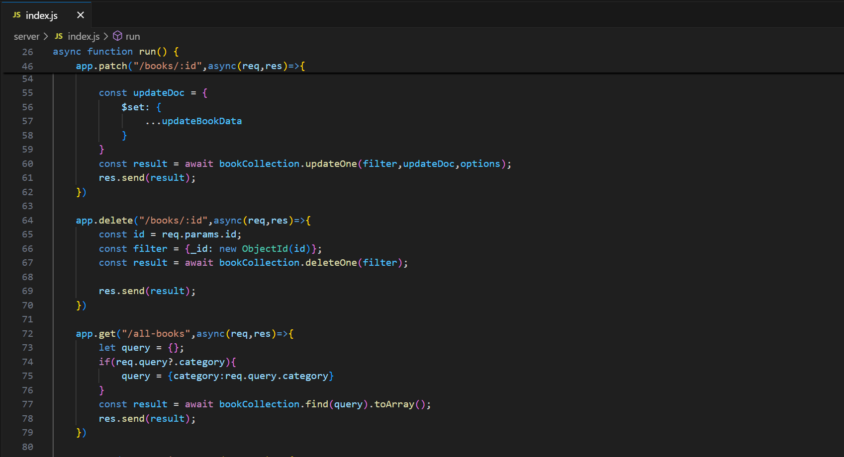

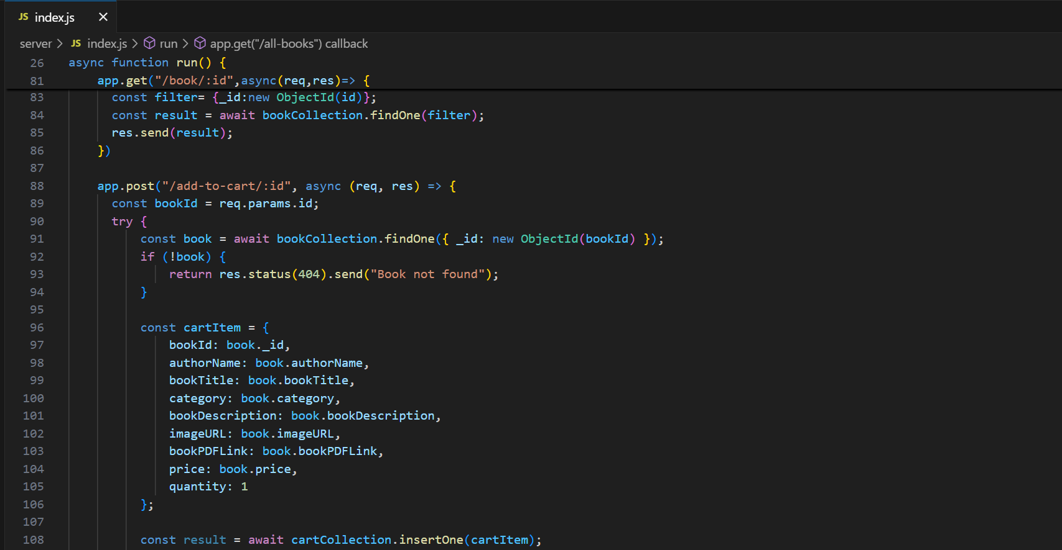

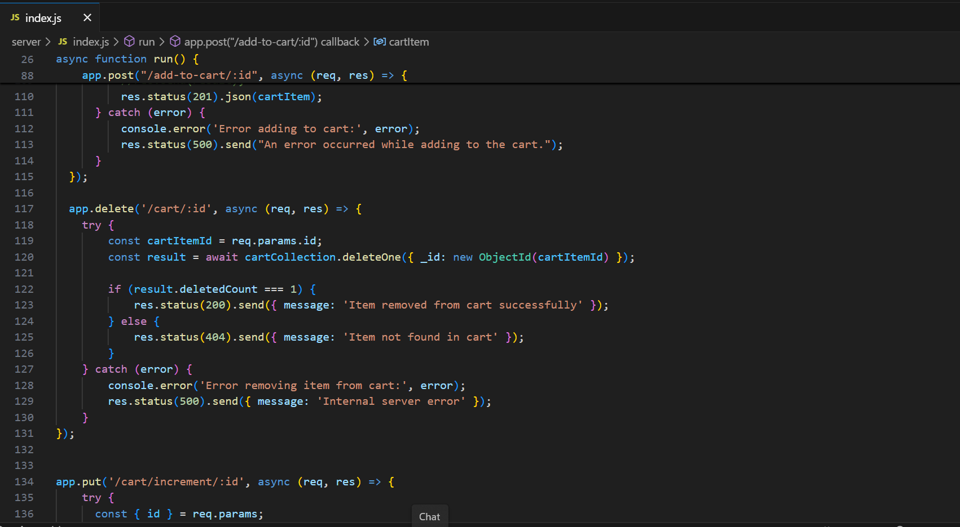

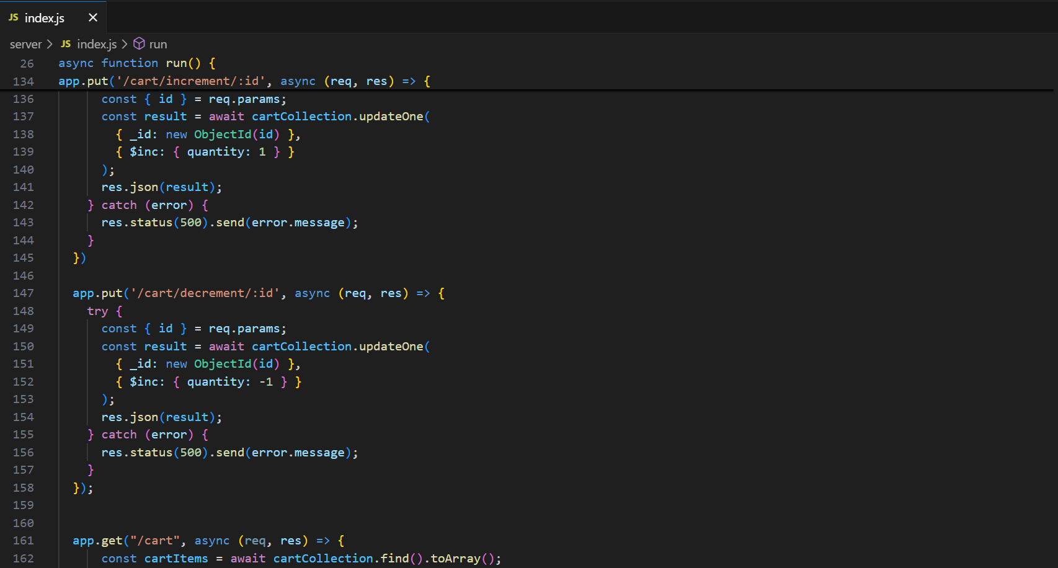

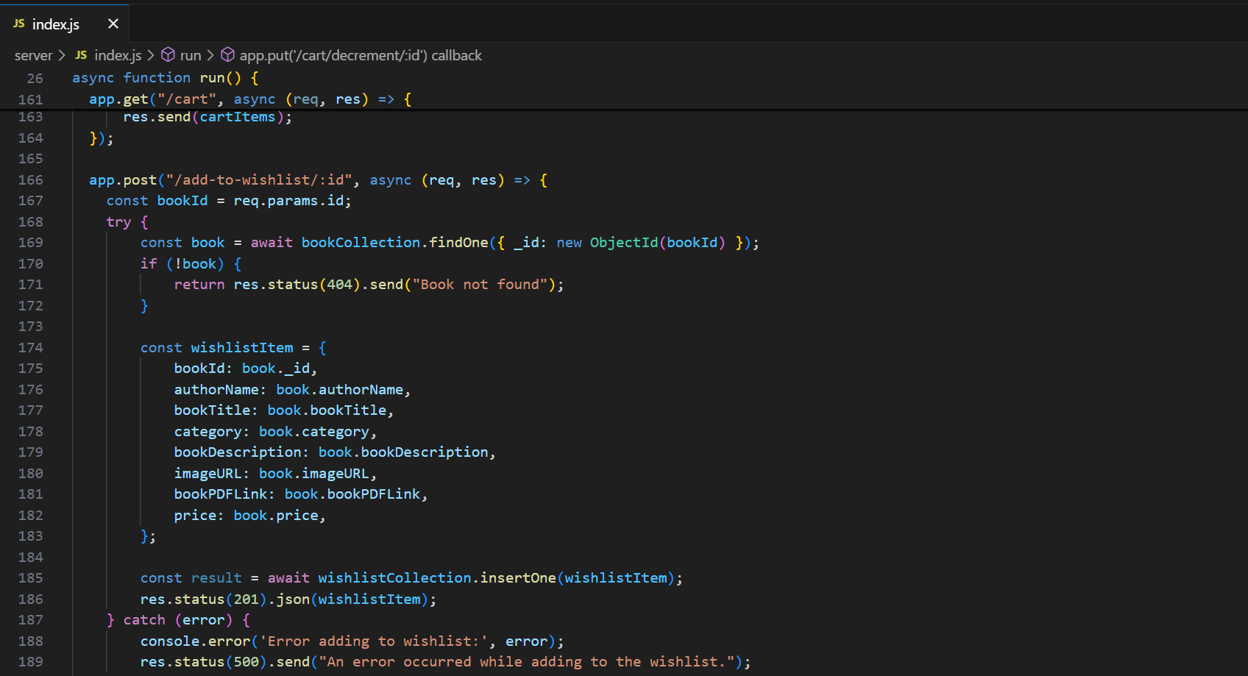

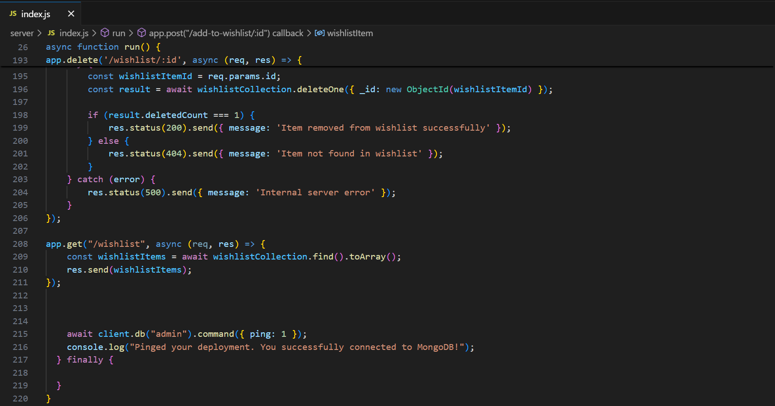

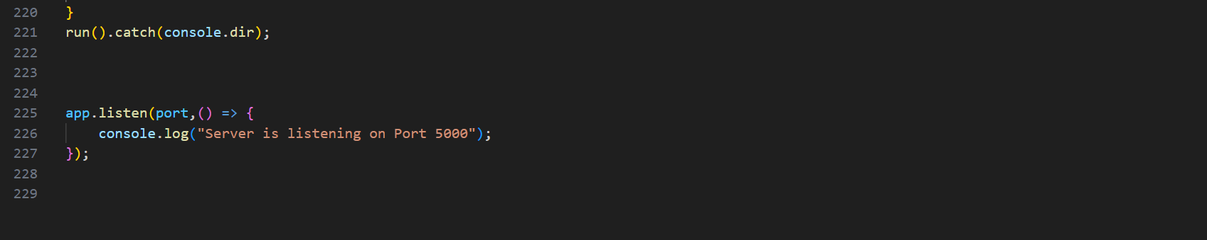

The backend APIs interact with MongoDB using Mongoose ODM Key interactions include:

* + Book Management: CRUD operations for books.
  + Cart Management: CRUD operations for cart items.
  + Wishlist Management: CRUD operations for wish list items.